The world of cars

**Project Plan**

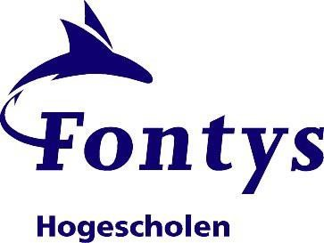

**Date:** 02-03-2024

**Group:** Atanas Dimitrov

**Version:** Version 1.0

**Status:** Open for Teachers

Project plan Individual assignment

Contents

1 Project definition 4

1.1 Client 4

1.2 Team 4

1.3 Current situation 4

1.4 Problem description 4

1.5 Project goal 4

1.6 Deliverables 4

1.7 Non-deliverable 4

1.8 Constraints 5

1.9 Risk Analysis (optional) 5

2 Phasing 5

# Project definition

The primary objective of this project is to develop both web and desktop applications interconnected through a shared database, aiming to deliver a comprehensive automotive experience. Focused on the theme of cars, the goal is to unite all elements essential to car enthusiasts within a single platform. The web application will serve as a central hub for enthusiasts and seekers of car knowledge, offering a plethora of features including detailed car profiles, up-to-date news, engaging community forums, and a user-friendly marketplace for selling cars through advertisements. This integrated platform will cater to the diverse needs of automotive enthusiasts, providing a seamless and immersive experience.

## Client

A client of the project is represented by Teun Cortooms and Mieke van Vucht, who are teachers at Fontis University of Applied Sciences.

Contact person: Teun Cortooms (WAD)

Email address: t.cortooms@fontys.nl

Contact person: Mieke van Vucht (OOD)

Email address: m.vanvucht@fontys.nl

## Team

Our team is represented by Atanas Dimitrov (a student at Fontys University), who will take care of the overall preparation of the project, together with its documentation.

## Current situation

The ground on which the Burj Khalifa will be built is desert, it is unstable and requires preparative work before it can host a building. The weather conditions are hot with occasional severe sandstorms. At this moment the world’s tallest building is the Taipei 101 at 508.2 meters tall.

## Problem description

Currently the amount of international recognition that Dubai receives as touristic location and location for investment opportunities is too small. The client is confident that this is due to the lack of “attention grabbing” landmarks.

## Project goal

The primary goal for this project is to gain more international recognition and promote investment and tourism in Dubai, to improve income streams from foreign sources.

## Deliverables

* Burj Dubai
* Engineering reports
* Design drawings
* Design documents
* Site investigation report

## Non-deliverable

• Maintenance plan

## Constraints

Budget: $ 1.4 billion

Work force: 14.000 workers

Initiation: 6 January 2004

Deadline: 1 October 2009

## Risk Analysis (optional)

*The risk analysis is done to make some agreements on how to negate the risks before you start the project. The described risks are threats towards the success of the project. For larger projects, these will include some typical project related risks. For example, when you build a house, the risk of a long frost period in which you cannot build. For smaller student run projects the risks are more related to the participation and group work of the student. Proper risk assessment should include more than just a definition per risk including: probability and impact.*

Within this project the following risks have been defined:

1. **Costs raise:** Increasing the prices of the raw materials or changing in the plan are one of the major obstacles
2. **Labor Strikes:** in such a big project, workers may stop working to pressure the employer to concede to their demands for improvements in wages, benefits, or work rules (e.g. Health Hazards due to hot temperatures in the desert, especially in a tough environment such as Dubai).

1. **Wind:** Wind loads are a structural challenge that the Burj Khalifa faced during and after construction. Vortex shedding, Twisting of the building, Safety of balcony users
2. **The Stack effect:** the warm air will rise to the top of the building while the cold air will try to fill the cracks in the bottom of the building. The problem this causes is that the pressure in the bottom can build up and can cause more cracking. **5. Load:** Lateral load, Gravity Load, Foundation

**6. Finance:** Insurance through various international financial organization, Cheap debt from stateowned companies for real estate projects.

# Phasing

Burj Khalifa is planned to be completed within 4 years. With an estimation of building 10 floors every month. The Gantt chart is the technique that will be used to manage the schedule of this project. Below is the Construction timeline schedule for Burj Khalifa:

+ January 2004, start Excavation

+ February 2004, start Piling

* March 2005, start Superstructure

+ June 2006, reach Level 50

+ January 2007, reach Level 100

* March 2007, reach Level 110
* April 2007, reach Level 120
* May 2007, reach Level 130

+ July 2007, reach Level 141

+ September 2007, reach Level 150

* April 2008, reach Level 160

+ January 2009, Completion of Spire

+ September 2009, complete exterior cladding

* January 2010, Official launch ceremony

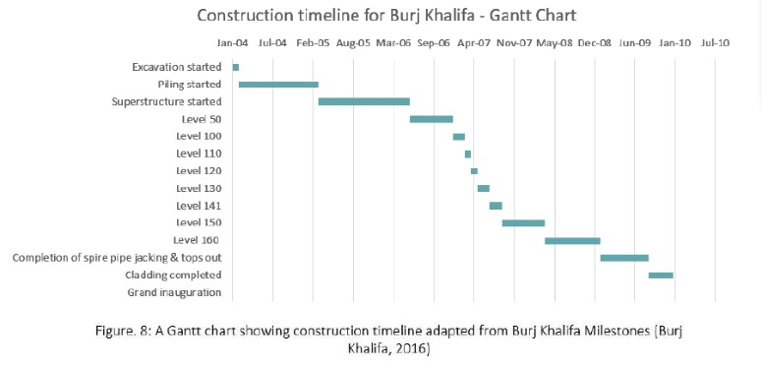

**Methodology**

‘Burj Khalifa’ project will adopt a **waterfall** methodology, this approach breaks stages down and requirements are defined early on. The approach used is the **SCRUM** method as no more than 30 days were needed to design, test, and construct the next floor to finish the project in time. ‘Burj Khalifa’ project will adopt an intense ‘3-day cycle’ strategy where a story is built every three days to allow workers to manageably complete work within a timeframe.